**DECLARATION**

I FRIKANG FAVOUR ANU-AKE hereby declares that, this work entitle “DESIGN AND IMPLEMENTATION OF A SCHOOL ATTENDANCE AND STUDENT ANONYMOUS FEEDBACK SYSTEM” was originally carried by me. It is an original piece of work, which has not been defended in any HND, PHD, Degree award anywhere, and all borrowed ideas have been acknowledge by means of reference.

SIGNATURE: ___________________________________________

DATE: _________________________________________________

**CERTIFICATION**

This is to certify that the project titled “ DESIGN AND IMPLEMENTATION OF A SCHOOL ATTENDANCE AND STUDENT ANONYMOUS FEEDBACK SYSTEM ” with case of ESCHOSYS TECHNOLOGIES is a record of independent research work done by FRIKANG FAVOUR ANU-AKE, under the supervision of MR. YUVEN CARLSON DZELAMONYUY and submitted to CITEC-HITM Yaoundé, for the award of an HND in Computer Software Engineering.

SUPERVISOR: MR. YUVEN CARLSON DZELAMONYUY

SIGNATURE OF THE SUPEREVISOR: ______________________________

Date: ___________________________________________________________

# DEDICATION

I dedicate this report to my family, the Frikangs.

**ACKNOWLEDGMENT**

Special thanks to my supervisor MR. YUVEN CARLSON DZELAMONYUY and the entire staff of CITEC HITM whose encouragement and relentless assistance, supervision and guidance were immeasurable in making this project a success. Big thanks goes to my field supervisor and the entire staff of ESCHOSYS TECHNOLOGIES for training me and impacting me with the knowledge and skills to carry out this project, My sincere gratitude is due to my dear Parents, MR FRIKANG JOSEPH and MRS FRIKANG GRACE who helped me succeed in this course by providing both material and moral support. I value my seniors in level three who also assisted me and helped me whenever i needed their help. Finally, I would want to convey my sincere thankfulness to God for enabling me to complete this piece of work by His hand of grace.

**ABSTRACT**

A **student attendance system** combined with an **anonymous feedback system** is a software application that automates attendance tracking and collects anonymous student feedback. This system is essential for schools, training centers, and universities, ensuring accurate attendance records and valuable student insights for effective teaching and administration.

The system allows instructors to mark and store attendance while generating reports accessible to students, teachers, and administrators. Additionally, it provides a platform for students to give anonymous feedback on lessons, teaching methods, other aspects and the learning environment without fear of identification or retribution. This ensures honest communication and helps institutions improve educational quality.

By integrating both attendance tracking and anonymous feedback, institutions can efficiently manage student engagement, enhance transparency, and continuously improve teaching methods. This system fosters a productive learning environment, Enhancing the experience for both students and educators by improving efficiency and fostering clearer communication.

**RESUME**

Un système d'assiduité combiné à un système de retour d'information anonyme est une application logicielle qui automatise le suivi de l'assiduité des étudiants et recueille leur retour d'information anonyme. Ce système est essentiel pour les écoles, les centres de formation et les universités, car il garantit l'exactitude des registres de présence des étudiants et permet d'obtenir des informations précieuses sur les étudiants pour un enseignement et une administration efficaces.

Le système permet aux enseignants de noter et de stocker les présences tout en générant des rapports accessibles aux étudiants, aux enseignants et aux administrateurs. En outre, il offre aux étudiants une plateforme leur permettant de donner un avis anonyme sur les cours, les méthodes d'enseignement, d'autres aspects et l'environnement d'apprentissage, sans crainte d'être identifiés ou de faire l'objet de représailles. Cela garantit une communication honnête et aide les institutions à améliorer la qualité de l'enseignement.

En intégrant à la fois le suivi des présences et les commentaires anonymes, les établissements peuvent gérer efficacement l'engagement des étudiants, renforcer la transparence et améliorer en permanence les méthodes d'enseignement. Ce système favorise un environnement d'apprentissage productif, améliorant l'expérience des étudiants et des éducateurs en améliorant l'efficacité et en favorisant une communication plus claire.

**TABLE OF CONTENT**

DECLARATION i

CERTIFICATION ii

DEDICATION iii

ACKNOWLEDGMENT iv

ABSTRACT v

RESUME vi

TABLE OF CONTENT vii

LIST OF TABLES xi

LIST OF FIGURES xii

LIST OF ABBREVIATIONS xiii

CHAPTER ONE: INTRODUCTION AND PRESENTATION OF ENTREPRISE 2

1.1 Background to the study 3

1.1.1 Historical background of the study. 3

1.1.2 Conceptual background 5

1.1.3 Theoretical background 5

1.1.4 Contextual background 6

1.2 STATEMENT OF THE PROBLEM 6

1.3 OBJECTIVES OF THE STUDY 7

1.3.1 Main objectives 7

1.3.2 Specific objectives 7

1.4 RESEARCH QUESTIONS 8

1.4.1 General research questions 8

1.4.2 Specific research questions 8

1.5 RESEARCH HYPOTHESIS 8

1.5.1 Main hypothesis 8

1.5.2 Specific hypothesis 9

1.6 SIGNIFICANCE OF THE STUDY 9

1.7 JUSTIFICATIONS OF THE STUDY 9

1.8 DELIMITATION OF THE STUDY 10

1.8.1 Thermatic Scope 10

1.8.2 Geographical scope 11

1.8.3 Time scope 11

1.9 ORGANIZATION OF THE STUDY 11

CHAPTER TWO: LITERATURE REVIEW 12

2.1 THEORETICAL REVIEW 12

2.2 CONCEPTUAL REVIEW 13

2.3 EMPERICAL REVIEW 14

2.4 PRESENTATION OF THE ENTERPRISE (INTERNSHIP) 15

2.4.1 PRESENTATION OF THE INTERSHIP 15

2.4.1.1 PRESENTATION OF THE DIFFERENT DEPARTMENT OF THE COMPANY 16

2.4.2 ACTIVITIES CARRIED OUT DURING THE INTERNSHIP 17

2.4.3 INTERNSHIP EXPERIENCE 18

2.4.4 STRENGTH AND WEAKNESS 18

2.4.4.1 STRENGTHS 18

2.4.4.2 WEAKNESSES 19

2.4.5 Problems encountered 19

2.4.6 RECOMMENDATIONS 20

CHAPTER 3: METHODOLOGY AND MATERIALS USED 22

3.1 INTRODUCTION 22

3.2 DESCRIPTION OF THE ARCHITECTURE OF THE SYSTEM OR APPLICATION 22

3.3 DATA COLLECTION METHOD AND USER’S NEED 23

3.3.1 OBSERVATION 23

3.3.2 1NTERVIEWS 24

3.3.3 EXPERIMENTS 24

3.3.4 USER’S NEEDS 25

3.4 FUNCTIONAL REQUIREMENTS 25

3.5 FUNCTION SPECIFICATIONS 25

3.5.1 ROLE PLAYED BY EACH ACTOR IN THE SYSTEM 25

3.5.2 FUNCTIONALITIES OF THE SYSTEM 26

3.6 TECHNICAL SPECIFICATIONS 26

3.7 NON-TECHNICAL SPECIFICATION 26

3.8 RESEARCH DESIGN 27

3.9 ANALYSIS METHODS 28

3.10 OBJECT- ORIENTED MODELING 28

3.10.1 Object Modelling Technique (OMT) Method 28

3.10.2 Unified Modelling Language (UML) Method 29

3.10.3 Unified Process (UP) Method 30

3.11 FUNCTIONAL METHODS 30

3.11.1 SADT Method 30

3.11.2 MERISE Method 31

3.12 CHOICE OF METHOD 33

3.13 APPLICATION OF METHOD 33

3.13.1 ACTORS 33

3.13.2 DIAGRAMS 34

3.13.3 COMPONENTS OF SYSTEM OR APPLICATION 36

3.13.3.1 HOME 36

3.13.3.2 LOGIN 36

3.13.3.3 Attendance 36

3.13.3.4 Users (Admin, teacher & Student) 36

3.13.3.5 Feedback 36

3.14 VARIOUS MODEL OF THE METHOD 36

3.14.1 DATA DICTIONARY 37

3.14.2 RULES TO MOVE FROM ONE DATA MODEL TO ANOTHER 37

3.15 SOFTWARE USED 38

3.15.1 Windows 10 Home 38

3.15.2 Design Environment (Win’ design) 38

3.15.3 Visual Studio Code (Text editor used) 38

3.15.4 Xampp Control Panel 38

3.15.5 PHPMYADMIN 38

3.15.6 E-Draw Max 38

3.15.7 YouTube 38

3.15.8 Google Chrome 39

3.16 PROGRAMMING LANGUAGES USED 39

3.16.1 HTML5 39

3.16.2 CSS 39

3.16.3 JAVASCRIPT 39

3.16.4 PHP 8.2.4 39

3.17 HARDWARE USED 39

3.18 MODULES OF THE DESIGNED SYSTEM 39

3.19 PHYSICAL ORGANIZATION (STRUCTURE) OF THE APPLICATION 40

CHAPTER FOUR 41

RESULT AND DISCUSSION 41

4.1 INTRODUCTION 41

4.2 RESULTS 41

4.3 PRESENTATION OF SCENARIOS AND A BRIEF EXPLANATION OF EACH SCENARIO 41

4.3.1 GENERAL HOME PAGE 41

4.3.2 ACTIVITIES (DASHBOARDS) 42

4.3.3 SCENARIO 1: WRITING FEEDBACK BY STUDENT 43

4.3.3 SCENARIO 2: ADMIN ADDING A NEW STUDENT TO THE SYSTEM 44

SCENARIO 3: ADMIN ADDING A NEW TEACHER TO THE SYSTEM 44

5.1 SUMMARY OF FINDINGS 45

5.2 DIFFICULTIES ENCOUNTERED 45

5.3 CONCLUSION 45

5.4 RECOMMENDATIONS 45

REFERENCES 46

Book References 46

APPENDIX 47

**LIST OF TABLES**

Table 1………………………………………….…………………………………………….18

Table 2 32

Table 3 37

**LIST OF FIGURES**

Figure 1 23

Figure 2 29

Figure 3 34

Figure 4 35

Figure 5 35

Figure 6: 40

Figure 7 41

Figure 8 42

Figure 9 42

Figure 10 43

Figure 11 43

Figure 12 43

Figure 13 44

Figure 14 44

**LIST OF ABBREVIATIONS**

CSS Cascading Stylesheet

HTTP Hyper-Text Transfer Protocol

PHP Hyper-Text Pre-processor

SQL Structured Query Language

WWW World wide web

UML Unified Modelling Language

XAMPP Apache, MySQL, PHP and Prel

SADT Structure Analysis and Design

IT Information Technology

PDU Protocol Data Unit

PC Personal Computer

**CHAPTER ONE: INTRODUCTION AND PRESENTATION OF ENTREPRISE**

**INTRODUCTION**

Many schools still make teachers write down attendance information by hand. Teachers have to write each student's name and then mark if they are present or absent. This takes a lot of time and is not a good use of the teacher's time. Because we are in a digital world and use the internet for a variety of activities, my project aims at managing students, their attendance and possible feedback that enables the students have a safe way to tell teachers what is wrong or right with the manner in which they teach lessons.

A good student attendance system is very important for any school. A good system makes it easy to track who is present and absent, helping teachers and administration know what is going on. More importantly, it helps identify students who might be missing class often so the school can provide support and figure out what's wrong. This early help is crucial for students to succeed. Plus, a reliable attendance system enhances school safety by knowing who's present, and ensures schools follow attendance rules. In short, a good attendance system helps create a safer and more supportive learning environment where everyone benefits.

Incorporating an anonymous student feedback system focusing on student’s ideas be it on teaching methods or others provides a safe and confidential space for students to share their honest perspectives on how teachers deliver lessons. This valuable tool empowers students to actively participate in shaping their learning environment by providing instructors with insights into what teaching strategies are effective and which areas need improvement. The anonymous nature of the system encourages honest feedback, free from fear of repercussions, allowing teachers to gain a clearer understanding of student experiences and make necessary adjustments to their teaching styles to better meet the diverse needs of their students. Ultimately, this feedback system fosters a more positive and effective learning environment for both students and teachers.

In today's educational scope, having a reliable and efficient student attendance and anonymous feedback system is no longer optional but very essential. A well-implemented system benefits both teachers and students in numerous ways, contributing to a more productive and positive learning environment for everyone. Here are some of the advantages of an attendance/feedback system to the

1. **Teachers:**

* Saves Time: Automated systems streamline attendance tracking, freeing up valuable time for teaching and interacting with students.
* Data-Driven Insights: Easily identify students with frequent absences or concerning attendance patterns for early intervention.
* Enhanced Classroom Management:Accurate attendance data contributes to a more structured and focused learning environment.
* Valuable Insights for Improvement: Anonymous feedback provides unbiased perspectives on teachers, their strengths and weaknesses depending on what the students write.
* Increased Self-Awareness**:** Teachers gain a deeper understanding of how their teaching is perceived by students, allowing for reflective practice and professional development.

1. **Students:**

* Increased Accountability: Regular attendance is encouraged, promoting a sense of responsibility and commitment to learning.
* Improved Academic Performance: Consistent attendance is strongly linked to better grades and overall academic success. Regular attendance instills habits of punctuality and responsibility, which are valuable in future academic and professional endeavors.
* Safe Space for Honest Feedback: Anonymity empowers students to express their opinions and concerns openly, without fear of judgment or negative repercussions.
* Evidence-Based Teaching Practices: Analyzing feedback patterns provides concrete data to support instructional decisions, leading to more data-driven and student-centered teaching.

**1.1 Background to the study**

The historical background, theoretical background, conceptual background, and contextual background of the research are all included in the background.

**Historical background.**

The historical background covers the background of the study.

**1.1.1 Historical background of the study.**

The search for effective education has always involved understanding student engagement and incorporating student perspectives. This has led to centuries of evolution in how we track attendance and gather feedback.

The earliest forms of attendance taking can be traced back to ancient civilizations like Greece and Rome. While rudimentary, their student rosters highlight a fundamental need: to track participation and allocate resources accordingly. However, it was the global push for compulsory education in the 19th and 20th centuries that cemented attendance records as a cornerstone of the education system. Governments demanded accurate data for funding and legal compliance, giving rise to the ubiquitous practice of teachers calling out names from a register – a system still recognizable in classrooms today.

The 20th century brought about technological advancements that trickled down from the business world. Just as factories adopted punch clocks for worker attendance, some schools experimented with similar systems for both teachers and students. However, these early attempts were often plagued by inaccuracies and vulnerabilities to manipulation. The dawn of the digital revolution in the latter part of the century ushered in a new era: computerized attendance systems. What began as simple databases evolved to incorporate barcode scanners and magnetic stripe cards, paving the way for more efficient and reliable tracking. Today, we stand at the cusp of a new frontier with biometric technologies like fingerprint scanning, facial recognition, and RFID tags. These sophisticated systems offer seamless and secure attendance tracking, often integrated with parent communication platforms to provide real-time updates and foster a more connected school community.

Similarly, the pursuit of student feedback has undergone its own transformation. Early attempts were characterized by low-tech solutions, often lacking structure and consistency. Physical suggestion boxes, while symbolizing openness, were easily overlooked and offered no guarantee of anonymity, hindering honest feedback. Mid-20th century efforts led to the standardization of student evaluations of teachers. These formal questionnaires, typically administered at the end of a term, provided valuable insights but lacked the immediacy needed for timely adjustments to teaching strategies.

The digital age, however, ushered in a new era of anonymous feedback systems. Online platforms and dedicated software provided a safe space for students to share their thoughts and concerns without fear of repercussions. The ability to provide feedback continuously throughout a term, rather than just at the end, allowed for more iterative improvement and demonstrated a commitment to incorporating student voices. Modern systems go beyond mere data collection; they leverage sophisticated data analysis tools to identify trends, measure the impact of interventions, and provide actionable insights to teachers. This data-driven approach, combined with the qualitative richness of student feedback, empowers educators to continuously refine their teaching practices and create a truly student-centric learning environment.

**1.1.2 Conceptual background**

This new system wants to make students a much bigger part of how their classrooms are run. It does this by using two main parts: keeping track of who's in class and giving students a safe way to say what they think about their teachers. Imagine a system where, alongside marking attendance, every student has the opportunity to share their honest opinions about the lessons, the teaching style, and anything else that affects their learning.

The key here is that the feedback is totally anonymous. This means students can speak freely, without worrying about getting in trouble or feeling embarrassed. They can say what they really think is working well and point out things they think could be done better. This direct feedback is incredibly valuable for teachers. Teachers can see what parts of their lessons are really clicking with the class and which parts might need to be explained differently or made more engaging.

At the same time, the system keeps a close eye on who's showing up for class. If a student starts missing a lot of school, it could be a sign that something's wrong. Maybe they're having trouble with the material, maybe something's going on at home, or maybe they need extra support. By connecting the dots between attendance and what students are saying anonymously, teachers can get a much better understanding of what's going on in their classrooms and how to help each student thrive.

**1.1.3 Theoretical background**

An attendance system serves as a vital tool for tracking student presence in class, enabling schools to monitor attendance patterns, assess student engagement, and ensure accurate record-keeping for administrative purposes. Alongside attendance, an anonymous feedback system empowers students to provide honest and constructive feedback on their teachers' performance without fear of repercussions. This feedback, collected anonymously, provides valuable insights for teachers to identify their strengths and weaknesses, tailor their teaching methods, and ultimately enhance the learning experience for their students. By combining attendance and anonymous feedback, schools can gain a holistic understanding of student engagement and teacher effectiveness, promoting a student-centered learning environment where continuous improvement is encouraged. The theoretical foundations for these systems lie in student-centered learning, constructivist theory, and quality improvement principles, highlighting the importance of understanding student needs, encouraging active student participation, and fostering a culture of continuous growth in education.

**1.1.4 Contextual background**

An attendance system and anonymous feedback system for students are essential components of modern educational institutions aiming to enhance classroom management and teacher effectiveness. These systems leverage technology to streamline administrative processes, gather valuable insights from students, and promote continuous improvement in teaching quality. The attendance system is a tool used to track and monitor students' presence in classes, lectures, and other educational activities. It helps educational institutions to ensure compliance with attendance policies, identify and address absenteeism issues, and improve student retention rates.

By automating the attendance tracking process, the system reduces the administrative burden on teachers and allows them to focus more on delivering quality instruction. Attendance data captured by the system can be used for performance evaluation, identification of at-risk students, and generation of reports for academic planning and resource allocation. The anonymous feedback system empowers students to provide constructive feedback on their teachers' performance without fear of retribution or bias. It promotes transparency, accountability, and student involvement in the evaluation and improvement of teaching practices.

Anonymous feedback can provide valuable insights into teaching effectiveness, classroom dynamics, and areas for professional development. Educational institutions can use feedback data to identify trends, assess teaching methodologies, and implement targeted interventions to enhance the overall learning experience. Implementing a feedback loop where teachers can review and respond to students' comments fosters a culture of continuous improvement and communication.

By combining an attendance system with an anonymous feedback system, educational institutions can create a comprehensive feedback mechanism that promotes student engagement, accountability, and growth. These systems contribute to building a positive learning environment, fostering constructive relationships between students and teachers, and driving overall educational excellence.

**1.2 STATEMENT OF THE PROBLEM**

Keeping track of student attendance and gathering honest feedback are common challenges in many schools and universities. Traditional attendance methods, like calling out names or using paper sign-in sheets, are time-consuming, prone to errors, and can be easily manipulated. On the other hand, students often hesitate to provide genuine feedback about their learning experience due to fear of being identified, which makes it difficult for institutions to address issues and improve the quality of education. Some of the key issues with the current system include:

* **Inaccurate Records** : Manually tracking attendance can lead to mistakes, whether accidental or intentional.
* **Time Wastage**: Taking attendance manually takes up valuable class time that could be used for learning.

Similarly, the absence of an **anonymous feedback system** causes:

* **Fear of Speaking Up**: Students may avoid giving honest feedback if they worry about consequences.
* **Missed Opportunities for Improvement**: Without honest student input, educators may not recognize areas that need change.
* **Inefficient Feedback Collection**: Traditional methods like suggestion boxes or surveys may not be structured or effective enough.

This project aims to develop a **combined attendance tracking and anonymous feedback system** to address these challenges. The digital attendance system will streamline attendance marking, reduce errors, and provide real-time data. At the same time, the anonymous feedback platform will give students a safe space to express their opinions without fear, helping institutions improve teaching and overall student experience.

**1.3 OBJECTIVES OF THE STUDY**

The objective of this study is divided into two, the main and the specific objectives.

**1.3.1 Main objectives**

The goal of this project is to design a student attendance and anonymous feedback system for ESCHOSYS TECHNOLOGIES.

**1.3.2 Specific objectives**

The specific objectives of this internship study are:

* Track and monitor student attendance accurately.
* Generate automated reports for each student's attendance record.
* Improve communication between administration and students regarding attendance requirements.
* Identify trends and patterns in attendance data to address at-risk students.
* Provide a confidential platform for students to share feedback.
* Collect constructive criticism and suggestions for improvement from students.
* Facilitate continuous improvement in teaching practices based on student feedback.
* Ensure that feedback is anonymous to encourage open and honest responses from students.

**1.4 RESEARCH QUESTIONS**

The research question is divided into two, the general research question and the specific research questions.

**1.4.1 General research questions**

Will the implementation of an attendance and anonymous system facilitate the analysis of trainee’s presence and absence and will it enable trainees comfortably give feedback on teachers.

**1.4.2 Specific research questions**

* In what ways does the anonymous feedback system facilitate open and honest communication from students regarding teaching methods?
* How do students perceive the value of providing feedback anonymously as opposed to non-anonymous methods?
* What specific improvements or changes have been implemented based on feedback received through the system?
* To what extent does the implementation of the attendance system affect students' attendance rates?
* How does the attendance system impact students' overall academic performance?
* What are students' perceptions of the effectiveness of the attendance system in promoting accountability and engagement?
* How does the use of the attendance system affect students' behavior and attitudes towards attendance and punctuality?

**1.5 RESEARCH HYPOTHESIS**

The research hypothesis of this study is divided into two types, the main and the specific hypothesis.

**1.5.1 Main hypothesis**

* The implementation of an attendance system will lead to higher overall student retention rates. Providing students with a platform to submit anonymous feedback on teaching methods will lead to increased student satisfaction with the quality of instruction.
* The integration of an attendance system and feedback system will result in enhanced communication between students and instructors, leading to a more positive learning environment overall

**1.5.2 Specific hypothesis**

* Students who regularly use the attendance system will have higher academic performance compared to those who do not utilize the system.
* There will be a positive correlation between students who attend classes regularly (as indicated by the attendance system) and their engagement in course materials.
* Feedback given by students will be taken into consideration and teaching methods or actions will be taken accordingly.

**1.6 SIGNIFICANCE OF THE STUDY**

* The significance of a study on an attendance system for students, coupled with an anonymous feedback system on teaching methods, lies in its potential to provide valuable insights for improving educational practices. By implementing an attendance system, educators can track student engagement and identify potential areas for intervention to ensure better student performance.
* Moreover, the feedback system allows students to provide honest and constructive criticisms of the teaching methods and overall learning experience. This feedback can help educators understand what works well and what needs improvement, leading to more effective teaching strategies and a more engaging learning environment.
* Overall, this study could contribute to enhancing the quality of education by fostering a more interactive and responsive approach to teaching and learning based on student feedback and attendance data.

**1.7 JUSTIFICATIONS OF THE STUDY**

The justification for implementing an attendance system for students and an anonymous feedback system where students can comment on teaching methods and other things can be multi-faceted:

* Enhancing Student Engagement: An attendance system helps ensure that students are attending classes regularly, which can lead to better learning outcomes. Additionally, providing students with a platform to give feedback on teaching methods can increase their engagement in the learning process and make them feel heard.
* Quality Improvement: The feedback provided by students can offer valuable insights into the effectiveness of teaching methods, helping instructors identify areas for improvement. This can ultimately lead to an enhanced learning experience for students.
* Accountability and Transparency: An attendance system can promote accountability among students to attend classes, while an anonymous feedback system allows students to express their opinions freely without fear of repercussions. This promotes transparency in the teaching and learning process.
* Continuous Improvement: By collecting feedback from students on an ongoing basis, instructors can continuously improve their teaching methods and adapt to the needs and preferences of their students. This can contribute to a more dynamic and effective learning environment.
* Student Satisfaction: Implementing systems that allow for student feedback demonstrates a commitment to student-centered education. Addressing student concerns and making improvements based on their feedback can lead to increased satisfaction and engagement among students.

**1.8 DELIMITATION OF THE STUDY**

* The study will focus solely on student attendance and feedback systems within a specific educational institution or program.
* The study will not explore other factors that could influence student attendance or feedback, such as personal traits, external circumstances, or institutional policies.
* The study will not consider the perspectives of other stakeholders, such as parents, or external evaluators.
* The study will not have other features of a student management system like the fee management; given that attendance and feedback are part of a student managaement system.

**1.8.1 Thermatic Scope**

The goal of this project, DESIGN AND IMPLEMENTATION OF A SCHOOL ATTENDANCE AND STUDENT ANONYMOUS FEEDBACK SYSTEM, case study ESCHOSYS TECHNOLOGIES, is to assist ESCHOSYS manage their trainee’s attendance and provide a platform where trainees can comfortably give their feed on trainers methods of teaching.

**1.8.2 Geographical scope**

The internship place is located opposite Hotel Mendjang at ACACIA, Yaoundé Center region.

**1.8.3 Time scope**

The internship period took place within three months from June 03rd 2024, until August 31st, 2024. The idea of this project came to me when I noticed how attendance was taken. For the feedback system, I got the idea when I needed to lay a complaint but felt uncomfortable telling the teachers because I didn’t want them knowing it came from me.

**1.9 ORGANIZATION OF THE STUDY**

This study is organized in five chapters;

* Chapter one provides and introduction to the study and discusses the scope of the study.
* Chapter two that presents the literature of the study.
* Chapter three, we have details of the methodology used in the study.
* Chapter four shows the result of the study, we see the different interfaces of the designed system.
* Chapter five, we have a summary, findings and recommendations on our study.

**CHAPTER TWO: LITERATURE REVIEW**

**INTRODUCTION**

In training centres, schools or even colleges, keeping track of student attendance and getting feedback from students about their classes are very important. Using the old-fashioned ways to do this can be difficult and take a lot of time. That's why people are looking at using technology to make these tasks easier and more effective. By putting together a system that checks student attendance and allows students to give feedback without revealing their identities, schools can make attendance management better, increase student involvement, and get useful insights to improve teaching methods. This literature review will look closely at the current research on how student attendance systems and anonymous feedback tools are being used in schools. By studying what others have already discovered, this review aims to explain the benefits, challenges, and outcomes of setting up this kind of system in educational institutions. It will also point out areas where more research is needed and suggest ideas for future studies in this field.

The literature review is a critical analysis of existing literature on a particular topic this case, an Attendance/Anonymous feedback system or research question. This chapter provides presentations of the internship activities as well as examining the review by theories, reviews by concepts and review by objective.

**2.1 THEORETICAL REVIEW**

This system integrates a student attendance system with an anonymous teacher feedback mechanism, which recognises the connection between presence, engagement, and student voice in fostering a positive learning environment. The system has several key educational theories:

**1. Student Attendance as Engagement Indicator:** While attendance alone doesn't guarantee learning, consistent presence is often correlated with active participation and a stronger sense of belonging, factors known to influence academic outcomes (Fredricks et al., 2004).As application, automated attendance tracking provides real-time data, enabling early identification of potential disengagement or issues hindering student presence.

**2. Student Empowerment and Feedback:** Student-centered learning emphasizes student agency. Empowering students to provide feedback on their learning experiences fosters a sense of ownership and values their perspectives in shaping teaching practices (McCombs & Whisler, 1997). The application of the anonymous feedback system gives students a voice without fear of reprisal, encouraging honest reflections on teaching methodologies and their impact on learning.

**3. Constructive Feedback for Improvement:** Constructivism views feedback as crucial for active learning and knowledge construction. Timely, specific, and actionable feedback helps students identify areas for growth and adjust their learning strategies (Hattie & Timperley, 2007). Applying the feedback system allows students to articulate their understanding, identify areas needing clarification, and participate in shaping a more responsive learning environment.

**4. Data-Driven Insights & Interventions:** Data-driven decision making leverages data to inform and improve practices. Analysing attendance patterns in conjunction with student feedback provides a more holistic understanding of student engagement and potential areas for intervention (Mandlawitz, 2019).The system generates both quantitative (attendance) and qualitative (feedback) data, allowing educators to identify trends, target support, and adapt teaching to better meet student needs.

**5. Ethical Data Use:** Ethical considerations including privacy, anonymity and informed consent, are paramount when collecting and utilizing student data (FERPA, 1974). It can be applied toprioritize student privacy through anonymous feedback and transparent data practices. The system is expected to have the following outcomes:

* **Improve Teacher Effectiveness**: Providing actionable feedback allows teachers to adjust their methodologies, fostering a more student-centered learning environment.
* **Enhance Student Engagement**: Addressing attendance barriers and giving students a voice can increase motivation, ownership, and active participation in learning.
* **Promote Data-Driven Culture**: The system encourages data-informed decision-making for continuous improvement in teaching practices and student support.

**2.2 CONCEPTUAL REVIEW**

Overall, this conceptual review will provide a comprehensive overview of the key concepts and theories related to an Integrated Student Attendance and Anonymous Teacher Feedback System, and will highlight core components of a system designed to enhance education through automated attendance tracking and confidential student feedback. We shall define various components of the study:

**1. Attendance:**

* Attendance Tracking: The process of recording and monitoring student presence in class, usually by marking them as present or absent. This data can be collected manually (e.g., roll call) or electronically (using attendance systems).
* Attendance Rate: The percentage of classes a student attends compared to the total number of classes scheduled. It's a key indicator of student engagement and academic success.

**2. Anonymous Teacher Feedback:**

* Anonymity: The concept that student feedback is provided without revealing the student's identity to the teacher(s). This is critical for fostering honesty, as students are more likely to express their true opinions and concerns without fear of reprisal.
* Feedback Analysis: The interpretation of feedback data to identify patterns, themes, and insights that can guide teacher development and improvement.

1. **Integration:**

* System Integration:The process of combining the attendance tracking and anonymous feedback systems into a single platform or application. This allows for data sharing, streamlined user experience, and a holistic view of student engagement.

**3. Security and Privacy:**

* Data Encryption: Protecting sensitive data, like student names and feedback responses, using encryption techniques to prevent unauthorized access.
* Access Control: Limiting access to data based on user roles and permissions, so only authorized individuals can view and modify information.
* Anonymity Protection: Ensuring that student identities are never revealed in the feedback system, even to the teacher.

**2.3 EMPERICAL REVIEW**

This empirical review aims to analyse and evaluate existing research studies related to student attendance and teacher anonymous feedback systems. Specifically, this review will examine the design and implementation of student attendance and teacher anonymous feedback systems, their impact on student performance, and the challenges and opportunities associated with these systems. By synthesizing existing research, this review will provide insights into best practices for student attendance and teacher anonymous feedback system design and implementation, as well as identify areas for future research and development. Below are some reviews on inventory management:

It is likely that many students hold back from answering or responding through peer pressure or the potential embarrassment of publicly giving the wrong answer. This in turn may mean that only the more confident or able student respond, when they are least in need of instructor attention (**Durbin & Durbin, 2006; Fies & Marshall, 2006; Kay, 2009**).

**Some studies include:**

* **"The Impact of Attendance on Student Achievement" (2018):** National Centre for Education Statistics (NCES) - Highlights attendance as a critical factor in student achievement.
* **"Automated Attendance Systems: A Review" (2020)**: Journal of Educational Technology Development and Exchange (JETDE) - Examines effectiveness and challenges of automated attendance systems.
* **"The Effects of Attendance on Student Engagement" (2019)**: Journal of Educational Psychology (JEP) - Investigates relationship between attendance and student engagement.
* **"School Attendance and Student Performance" (2017):** Education Economics (EE) - Analyzes attendance impact on student performance.
* **"Attendance and Academic Achievement" (2016)**: Journal of Educational Research (JER) - Explores attendance-academic achievement correlation.
* **"Anonymous Feedback Systems: A Study of Student Perceptions" (2020)**: Journal of Educational Technology Development and Exchange (JETDE). Explores student attitudes toward anonymous feedback systems.
* **"The Impact of Anonymous Feedback on Teaching Practices" (2019)**: Journal of Educational Psychology (JEP). Investigates how anonymous feedback influences teaching methods.
* **"Student Anonymous Feedback: A Tool for Improvement" (2018):** Education and Urban Society (EUS). Examines the potential of anonymous feedback for school improvement.
* **"Anonymous Online Feedback: A Study of Student Engagement" (2017)**: Journal of Educational Multimedia and Hypermedia (JEMH). Analyses the relationship between anonymous feedback and student engagement.
* **"The Effectiveness of Anonymous Feedback Systems" (2016)**: Journal of Educational Research (JER). Evaluates the effectiveness of anonymous feedback systems.

**2.4 PRESENTATION OF THE ENTERPRISE (INTERNSHIP)**

The description of the internship site and the internship activities are included in this section of the study.

**2.4.1 PRESENTATION OF THE INTERSHIP**

**ESCHOSYS TECHNOLOGIES** is a tech company that is geared towards leveraging tech services, solutions and training to the Cameroonian population and those abroad. The company is founded by Lwanga Anslem Fomonyuy a tech-preneur whose passion is aimed at encouraging young Cameroonians to embrace tech and use technology in generating income for sustainable leaving standards. He founded ESCHOSYS in 2022 and it started its timid operations in the early days of 2023 and became fully operational in as from the 3rd of June 2024.

It is found in Cameroon, the nation’s political capital Yaounde precisely in the Nfundi division (Yaounde IV). It is located at Accassia neighbourhood behind Mendjang Restaurant (20 metres from Mendjang Restaurant).

ESCHOSYS TECHNOLOGIES is a tech company which is highly involved in different tech activities like: software development (frontend and backend), android application development, data analysis, data analytics, installation and configuration of cameras (CCTV and I.P cameras), installation and configuration of solar panels, installation and configuration of satellite antennas, graphic design (Adobe photoshop, Adobe illustrator, Indesign etc), writing of scientific articles and assistance in project writing, assembling and flying of drones, computer hardware maintenance, installation and configuration of computer networks, digital marketing (running of facebook ads, google ads), search engine optimisation (SEO), cyber security and ethical hacking services (reverse engineering), installation and configuration of GPS, setting up smart homes, embedded system services and desktop application development.

**2.4.1.1 PRESENTATION OF THE DIFFERENT DEPARTMENT OF THE COMPANY**

ESCHOSYS TECHNOLOGIES is a sun rising Tech Company that is made up of few but active departments. Some of the functional departments in ESCHOSYS are:

1. **The I.T (Information technology) department**

This department serves as the live wire of ESCHOSYS. This is so because ESCHOSYS is a tech company that most deal with tech solutions, services or products and all the tech personnels are highly involved in all the tech activities

1. **The marketing department**

This is a very important department at ESCHOSYS because it is responsible for marketing the company products, creating awareness of internship opportunities, available training programs and courses and making available prominent services of the company like a learning management system (LMS) that serves as an e-learning platform for customers (schools) and for the company in particular

1. **The public relationship department**

This department ensures that contracts and partnership agreement between ESCHOSYS and her customers is materialized and effectively executed

1. **The human resource management department**

This department is in charge of recruiting new trainers/professionals are recruited into the company based on severe recruitment procedures

1. **The management department**

This department oversees all the different activities of the company and ensures that management is at its peak performance to guarantee the wellbeing and sustainability of the company.

**2.4.2 ACTIVITIES CARRIED OUT DURING THE INTERNSHIP**

|  |  |
| --- | --- |
| **WEEK** | **ACTIVITIES** |
| Week 1 and 2 | * Presentation of the internship place and various fields to be taught * Design of logos using Adobe illustrator * Design of flyers using Adobe Photoshop * Html and CSS basics |
| Week 3 and 4 | * Building of web pages using Html, CSS and Javascript * Introduction to Cyber security |
| Week 5 and 6 | * Building of web pages using Wordpress * Building web pages using frameworks like Bootstrap and Tailwindcss |
| Week 7 and 8 | * Introduction to php and linking databases * Introduction to Visual studio (.NET framework) |
| Week 9 and 10 | * Building websites and how to host them on the internet and push to github account * Basics on Node.js |
| Week 11 and 12 | * Assessment and evaluation |

Table 1 : Activities carried out during internship

**2.4.3 INTERNSHIP EXPERIENCE**

My internship experience was a good one. I had the privilege to learn a lot of things which include;

* Building of web pages and hosting using Html, CSS, Javascript and PHP
* Building of webpages using Wordpress, Bootstrap and Tailwindcss
* Cyber security
* Visual studio (.NET framework)
* Adobe photoshop and Illustrator.

**2.4.4 STRENGTH AND WEAKNESS**

This part of the work contains the strengths and weaknesses of the internship place.

**2.4.4.1 STRENGTHS**

Though ESCHOSYS TECHNOLOGIES is a sun rising Tech Company, there exist many merits that makes ESCHOSYS outweigh other tech companies. Some of these advantages that make the company powerful are:

**1. Innovation and Cutting-Edge Technology**

Unlike other tech companies, ESCHOSYS has embrassed technology and deal with licensed software and purchase software product without solely relying on null resources which can fail at any given time. Also ESCHOSYS has good soft ski9lls that permit IoT services to be integrated in their services.

**2. Quality and Reliability**

* + High-Quality Standards: Ensuring that products and services meet the highest quality standards, ESCHOSYS also ensure that training offered to trainees and services rendered are of quality based on feedback and testimonies from customers.
  + Reliability and Performance: they offer reliable and high-performance solutions that customers can depend on.

**3. Customer-Centric Approach (customer satisfaction)**

* + The tech team of ESCHOSYS are always on the fact that when the customers are satisfied, they will also be satisfied. By so doing, the customers turn to get the best from ESCHOSYS team

**4. Skilled and Experienced Team**

* + Expertise: ESCHOSYS has a team of highly skilled and experienced professionals who are experts in their respective fields.
  + Continuous Learning: Encouraging ongoing training and professional development to keep the team updated with the latest technologies is a sole responsibility of the management of ESCHOSYS.

**5. Strategic Partnerships and Alliances**

ESCHOSYS via their public relation offer is aimed at ensuring that the company secures good partnership deals which end up benefiting the company as compared to other tech companies

**6. Feedback**

A survey is regularly conducted at ESCHOSYS by the management to get feedback from trainees, customers and what would be customer will desire to have. With all of these, mistakes are quickly correct on time before the escalate to severe irreparable problems

**7. Free services/Customer service**

ESCHOSYS render some services like computer maintenance to her customers especially interns who are in the company. Also, ESCHOSYS is flexible in her payment policies and constant follow up of trainees and customers to ensure the best of what they wanted is gotten.

**2.4.4.2 WEAKNESSES**

Though there might be so many positive aspects about ESCHOSYS, there are also some few drawbacks that need adjustments. Some of these drawbacks are:

* + - 1. **Marketing**

At times the marketing team is very lax and this goes a long way to retard the visibility of the company and the services offered by the company as a whole.

* + - 1. **Punctuality of trainers/Tech professionals**

Provided that most of the tech professionals of ESCHOSYS develop software into the late hours of the night, they mostly come late to the company. This goes a long way to affect the stipulated objectives and the company objectives as whole and expected outcomes.

**2.4.5 Problems encountered**

Though ESCHOSYS was best of an internship place, there are also challenges encountered carrying out internship. Some of the challenges encountered are:

* **Lack of a safe and confidential platform to lay my worries an intern**

During the internship period, I had difficulties in sharing my concerns, suggestions

and feedback regarding the methods used by the instructors to educate us. This was due to a fear of retaliation or judgment from the instructors or from other students. Hence, there were many unaddressed concerns which limited my rate of grasping knowledge and personal satisfaction.

* **Transportation**

It was not very easy to continuously carry out internship for all working internship days at ESCHOSYS. They were days that I as the trainee could not make it at the internship place because of taxi fare since I was living relatively far from the internship place.

* **Internship fee**

With the aim to purchase the necessary material needed by the trainers to transmit skills, there was need for a minimal amount as internship fee. This was still a problem to the intern as at given moments raising transport and raising the internship fee was a bit difficult

* **Language challenges**

Helping out fellow internship mates and friends with some difficulties because they could not master the language (English or French) some of the software were installed or the trainers were teaching is another challenge. This ending up with a good experience because modern AI tools that have aided translation and configuring of software. Communicating fluently with those of purely French background was also a challenge

**2.4.6 RECOMMENDATIONS**

Some of the few recommendations as regards the various challenges and weaknesses encountered at ESCHOSYS TECHNOLOGIES are:

* **Provision of an anonymous platform where students can lay their complaints**

Doing this will help students comfortably talk of their difficulties and maybe give the reasons for those difficulties (which could be the method used to educate them).

* **Assiduity**

Trainers should always endeavour to be on time at the company. This will go a long way to meet company objectives and the internship program scheduled for the period available

* **Marketing**

The management of ESCHOSYS should cease from giving a blind eye to the laxity of the marketing department. If serious measures are not taken, the might loss popularity and visibility to the entire world provided is just a sun rising company.

**CHAPTER 3: METHODOLOGY AND MATERIALS USED**

**3.1 INTRODUCTION**

The word "methodology" refers to a process for determining the best solutions to a problem. We use this process to accomplish our primary or targeted goals. When thinking about how to create a system that keeps track of student attendance and allows them to give feedback without revealing their identities, it's important to look at the methods and tools used. By exploring different ways and technologies, we hope to design a system that is easy to use and efficient for both students and teachers. This section will outline the steps taken to develop and implement the student attendance and anonymous feedback system. Various tools will be explored, techniques, and software to create a system that meets the needs of everyone involved. This methodology will help in understanding how to collect attendance information, keep feedback anonymous, and use technology to enhance the educational experience. By carefully examining the tools and strategies available, the goal is to create a system that works smoothly and benefits the entire educational community.

**3.2 DESCRIPTION OF THE ARCHITECTURE OF THE SYSTEM OR APPLICATION**

The conception of a good application entails the designer to select the best technology, the appropriate tools, the adapted software necessary and not forgetting to respect the methodology to be used in order to realize the platform and satisfy users with their needs. The architecture of a web application here is talking about an approach to the design and planning of websites that involves technical, aesthetic and functional criteria. As in traditional architecture, the focus is on the user and on user requirements. It also entails employing software, human resources, techniques and information flow in the system.

In a typically 3-tiered architecture, users point their browsers to the application server to start using the application. However, the setup of that environment can be considerably more complex than setting up a database for the users to connect to, and making the installer for the client available. 3-tier for users is the most advantageous of these tiers and this is why it has been chosen as our architecture of preference and because 3-tier has the potential of greater speed and security than the 2-tier architecture. Due to the importance of this web applications and the organization in which the information shall flow within the information system, we have chosen the 3-tier architecture which involves the following points:

* Data are shared on a focal point
* The layout of the application is taken in charge by the computer-client
* Application server also named middleware is the one in charge of providing the resources by calling another server named database server.

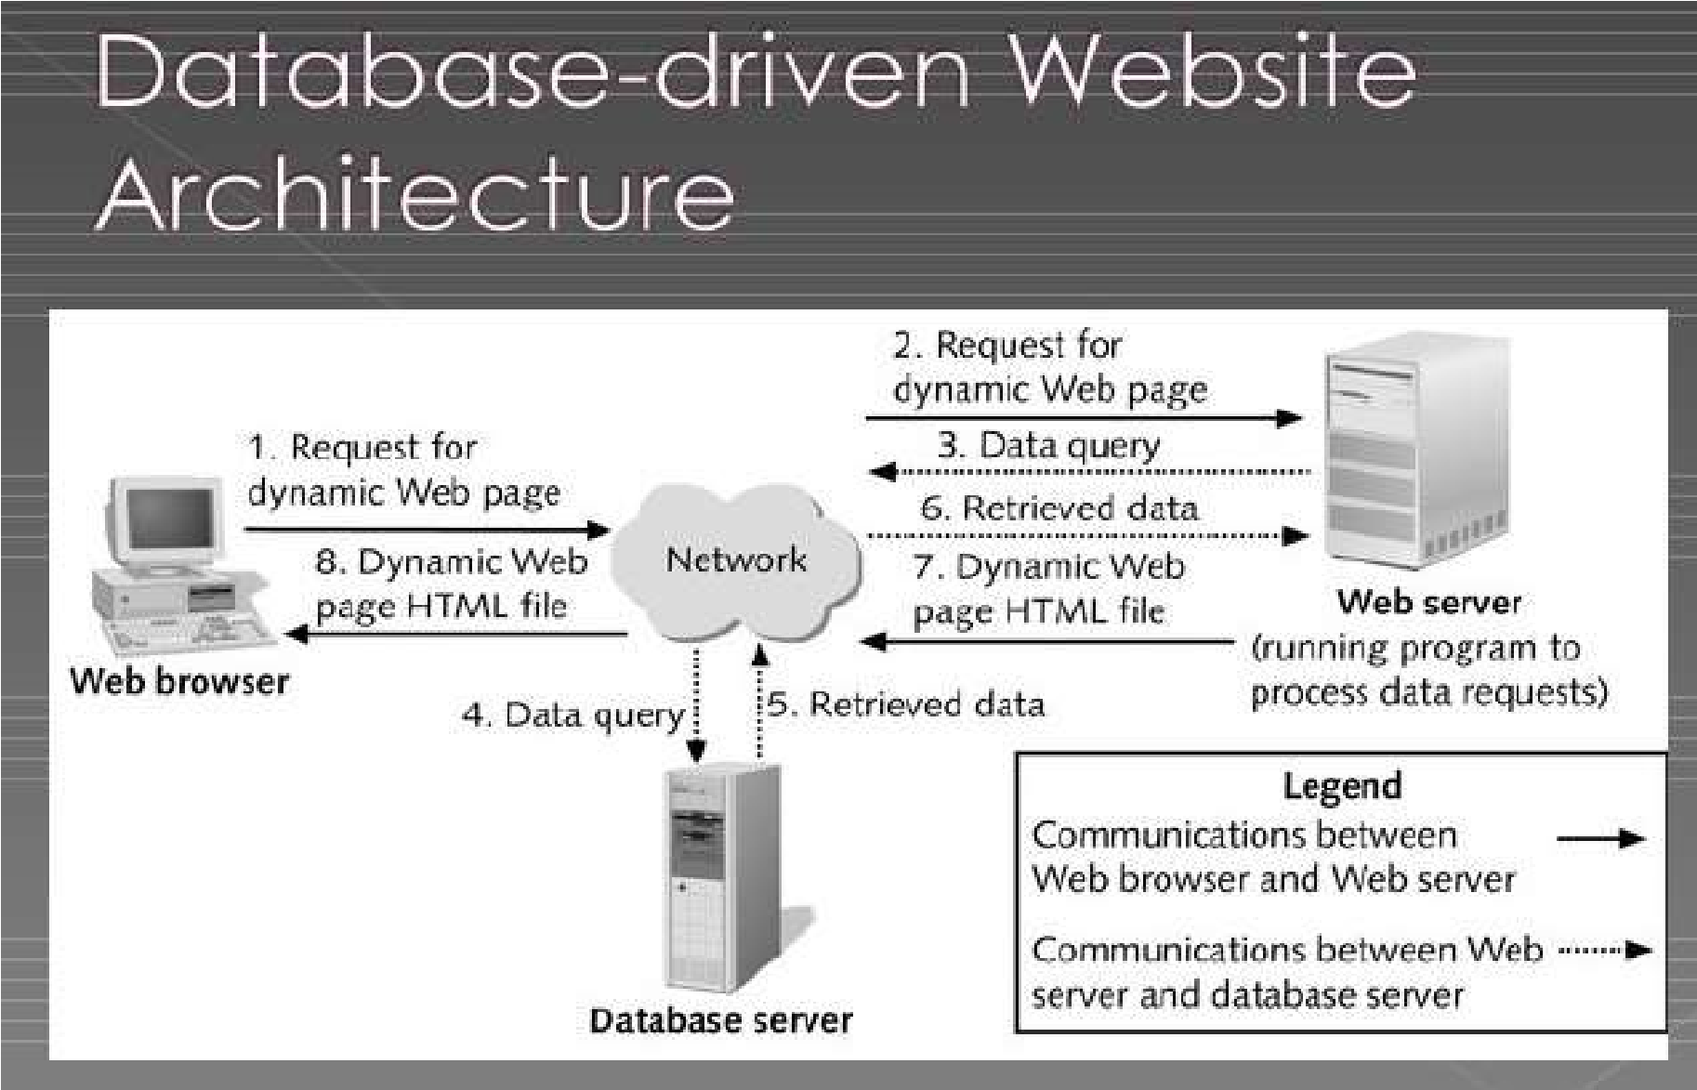The figure below represents a 3-tier architecture where we have the client, database and the application servers which is the choice for our dissertation:

Figure 1: Architecture of the system -source: (www.slideshare.net)

**3.3 DATA COLLECTION METHOD AND USER’S NEED**

A good web application should take into account the assembly of data collection and user’s needs. It is not possible to realize a web application without studying the information system. So, a good web application should answer the user’s needs with the help of the various methods of data collection put in place. However, the choice of a particular data collection method to be used depends on the objectives the researcher wants to attain at the end. As part of our research, we have chosen to gather information and ascertain users' demands through interview and observation.

**3.3.1 OBSERVATION**

In observing the implementation of a system that combines student attendance tracking with an anonymous feedback platform, it becomes evident that the integration of technology plays a crucial role in streamlining educational processes. The system facilitates the seamless monitoring of student presence in classes while providing a channel for students to share their perspectives without the fear of identification. Through this observation, it is clear that leveraging modern tools and methodologies can enhance communication between students and educators, leading to a more inclusive and responsive learning environment. The observation highlights the potential of such a system to foster transparency, improve student engagement, and tailor teaching approaches to better meet the needs of learners. As the system continues to be utilized, on-going observations will be essential in evaluating its impact on student participation, feedback quality, and overall educational outcomes.

**3.3.2 1NTERVIEWS**

During the development and evaluation of a system that integrates student attendance tracking and anonymous feedback mechanisms, interviews play a vital role in gaining valuable insights from stakeholders. These interviews involve interacting with students, faculty, and administrators to understand their perspectives, requirements, and expectations regarding the system. The interviews aim to gather feedback on the usability, effectiveness, and overall usability of the system. The findings from these interviews can help identify potential issues, improve system functionality, and ensure that it meets end-user requirements and preferences. Interviews also provide an opportunity to include valuable suggestions and feedback from stakeholders, ultimately contributing to the successful implementation and improvement of the student attendance and anonymous feedback system.

**3.3.3 EXPERIMENTS**

Several experiments can be conducted to test and validate the effectiveness of a system that combines student attendance tracking and an anonymous feedback platform. These experiments are designed to evaluate various aspects of the system, including its functionality, usability, student engagement, and its impact on feedback quality. Some potential experiments include:

1. Usability Testing: Conduct usability testing sessions with students and teachers to evaluate the ease of use and navigation of the system. Participants can perform specific tasks on the system and provide feedback on their experiences.
2. Feedback Quality Assessment: Analyze feedback collected through the system to assess the quality, relevance, and constructiveness of anonymous comments. This allows us to understand the value of the feedback received and identify areas for improvement.
3. System Performance Assessment: Test system performance under a variety of user loads and scenarios to ensure system stability, responsiveness, and scalability. The purpose of this experiment is to identify potential bottlenecks or issues in the system.
4. Impact on Student Engagement: Conduct surveys or observational studies to assess the impact of the system on student engagement, attendance, and overall interaction with course materials.
5. Satisfaction Survey: Collect feedback from students, faculty, and administrators through surveys to assess their satisfaction with the system and solicit suggestions for further improvements

**3.3.4 USER’S NEEDS**

A relevant web application should be designed according to the users’ needs, because a good developer or a programmer must not realize a web application without taking in to account the users’ needs. The students need to be assured that their feedback will indeed be anonymous and their attendance is well analysed and taken down by teachers.

**3.4 FUNCTIONAL REQUIREMENTS**

In this light, we are looking at the various basic computer components needed to permit our application function well and serve its intended audience. Some of these components (requirements) are; a good RAM, processor, hard disk and peripheral input and output devices (monitor, mouse and keyboard).

**3.5 FUNCTION SPECIFICATIONS**

The functional specification includes actors which will interact to actually bring out the role of this application at ESCHOSYS TECHNOLOGY and at the society and how this application will play this role with the help of its actors which we are to discuss below:

**3.5.1 ROLE PLAYED BY EACH ACTOR IN THE SYSTEM**

Administrator

* Adds teachers
* Adds students
* Views attendance
* Marks attendance
* Views feedback
* Removes teacher
* Removes student

Teacher

* Marks attendance
* Sends documents
* Views feedback
* Adds student
* Removes student

Student

* Adds feedback on teacher
* Uploads documents
* Likes feed
* Dislike feed

**3.5.2 FUNCTIONALITIES OF THE SYSTEM**

The most important functionalities of the system involve:

1. Automatic attendance tracking: This feature allows students to mark their attendance electronically, saving time and providing accurate attendance records for teachers to monitor.
2. Anonymous Feedback Platform: Providing students with the ability to provide anonymous feedback is critical to providing honest, constructive feedback that can help improve teaching methods and course content.
3. Data Analysis and Reporting: The ability to analyse attendance trends and feedback data, present it visually, and gain insights from the data is essential to making informed decisions and improving the overall educational experience.

**3.6 TECHNICAL SPECIFICATIONS**

1. A login page for the actors in the system should be included on the main page.
2. The platform should display an interface here the administrators can login into the system.
3. Both the admin and the teacher have a similar home page but with a difference in the level of their various menus
   1. **NON-TECHNICAL SPECIFICATION**

* **At the level of security:** Like any web application that we have the chance to visit the administrators won’t be able to log in to any other administrators account without prior authorization from the administrator. Here, each administrator account is confidential to him or her.
* **Performance level:** The internet connection should be very fast with ahigh bandwidth.
* **Scalability:** The system should be scalable to accommodate the needs of growing businesses. It should be able to handle increasing transaction volumes without compromising performance or functionality.

**3.8 RESEARCH DESIGN**

The research seeks to explore how the implementation of an integrative student attendance and anonymous feedback system affects the communication processes and involvement of students within the academic processes.

Participants will include university students and teachers from different departments in the institution.

**Methodology:**

* Design: The research will employ quasi experimental design in which there will be a comparison of outcomes with a control experimental group applying conventional ways of recording attendance and giving feedback as opposed to the experimental that will use the integrated system.
* Data Collection: Quantitative data concerning how many students attended classes, how many students provided feedback, how many times students interacted with the system’s components will be recorded and statistics generated. Moreover, other qualitative data will be obtained through the use of surveys or focus groups to obtain user’s views and experiences.

**Some of the importance of this to the various stakeholders includes:**

For Teachers

* **Enhanced Understanding:** The system has provisions that allow an easy way for teachers to monitor attendance and the reporting of students’ absences and late arrivals or the prevalence of such trends which would aid in taking action in good time.

For Students

* **Providing Feedback**: Helps learners address their issues, including class related concerns, or suggestions about the course to remain anonymous as to allow maximum critique.

For Administrators

* **Management by Objectives**: Provides access to current information on attendance in particular lectures and opinions about them, which is important for improving the academic process and helping the students.

# 3.9 ANALYSIS METHODS

The scientific approach method is that which the researcher is guided to make appropriate software and that method entails an analysis which makes the design of a web application such as this to be put in place. This involves first of all the collection of information on the field passing through the need and flow of information within a particular information system in order to design software closely to the users’ needs. We will step by step look through or present the different types of methods under the large set: The object-oriented methods and the functional methods. At the end we will precise the best method suitable in the realization of our web application by giving the raisons d’être of our choice.

# 3.10 OBJECT- ORIENTED MODELING

The Object-oriented methods (OOMs) describe the static structure of the objects, their classes and their relations. One can mention here the following OOMs: OMT method, UML method and UP.

## 3.10.1 Object Modelling Technique (OMT) Method

The Object Modelling Technique (OMT) is an object modelling method for software modelling and designing. It was developed around 1991 by Rumbaugh, Blaha, Premerlani, Eddy and Lorensen as a method to develop object-oriented systems and to support object-oriented programming (ESPINASSE, 1980). OMT was developed as an approach to software development. The purposes of this modelling according to Rumbaugh are:

1. Testing physical entities before building them (simulation).
2. Communication with customers.
3. Conception (alternative presentation of information).
4. Reduction of complexity.

**OMT has proposed three main types of models:**

1. **Object model:** The object model represents the static and most stable phenomena in the model domain. Main concepts are classes and associations with attributes and operations.
2. **Dynamic model:** The dynamic model represents a state or transition view on the model.

Main concepts are states, transition between states and event to trigger transitions. Actions can be modelled as occurring within states. Generalization and aggregation (concurrency) are predefined relationships.

1. **Functional model:** The functional model handles the process perspective of the model, corresponding roughly to data flow diagrams. Main concepts are process, data, data flow and actors.

## 3.10.2 Unified Modelling Language (UML) Method

UML is a language of modelling unified object in an object-oriented environment developed in response to the call for the proposal launched by the Object Management Group (OMG) with the goal of defining the standard notation for the modelling of applications built using objects. The principal authors of UML are Grady Booch, Ivvar Jacobson and Jim Rumbaugh.

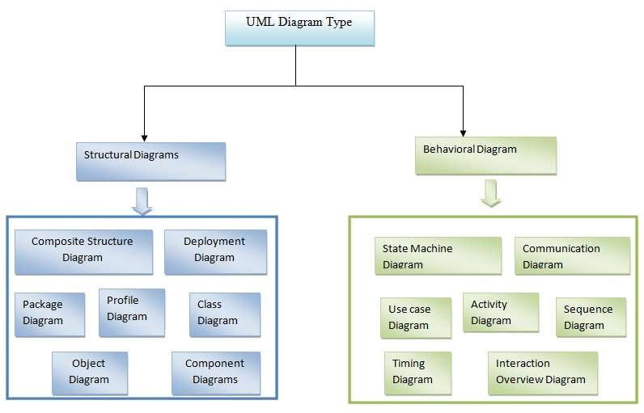

### Figure 2: Overview of UML -source : (static3.creately.com)

Some advantages of UML are:

* Formal and standardized language, it allows proceeds of precision and constitutes a pledge of stability. This is what encourages the use of the tools.
* Powerful support of communication.
* Implementation of all the richness of the object approach.
* Description of all the models from the analysis to the realization of the software.
* Standardization of the concept’s objects.

Some limits of UML are:

* The semantics of UML is not formalized. It is specified by using the natural language.
* Difficult optimization of the choice of the classes.

Various categories of diagrams are not formalized.

## 3.10.3 Unified Process (UP) Method

Unified Process (UP) is a management method in the life cycle of software development and thus for object-oriented software. This as a generic method, iterative and incremental unlike the sequential method MERISE or SADT. This method is the general precept methods with the abbreviations: RUP, UPA, XUP, EUP, 2TUP, AM, DCU. Thus, an embodiment according to UP, to transform the software needs of users, must necessarily have the following characteristics:

* UP is based on components
* UP uses UML
* UP is driven by use cases
* UP centric architecture
* UP is iterative and incremental.

Some advantages of UP are:

* Use case sensitive
* Architecture centric
* Iterative and incremental.

Some limits of UP are:

* It is used only at the beginning of the whole process to create business requirements.
* The final application reflects the business processes, but there exist no closer bond between them.
* A small change in the business process leads to a fundamental change of the created information system.

# 3.11 FUNCTIONAL METHODS

The functional methods have their origin in the development of the procedural languages. More directed towards the managements than towards the data, they highlight the functions to be ensured and propose a hierarchical, downward and modular approach by specifying the bonds between the various modules. With the evolution of systems and programming languages, these methods took into account the modelling of the data and the problems arising from real time.

## 3.11.1 SADT Method

Structured Analysis and Design Technique (SADT) Method is a method of American origin developed in 1977 by DOUG ROSS then introduced in Europe since 1982 by Michel GALINER. It is a multi-field language which supports the communication between users and originators. As a method of functional analysis and the most known management of projects, SADT presents strong points and weak points.

Some advantages of SADT Method are:

* Its simplicity
* Its adequacy to capture the user's needs
* Its capacity with being able to produce solutions on several levels of abstraction.

Some limits of SADT Method: are:

* Its analysis is concentrated much on the functions, the coherence of the data being neglected.
* The rules of decomposition are not explicit. The decomposition differs according to analysts.
* Its difficulties of taking account of the non-hierarchical interactions in the complex systems.
* Lastly, the volatility of the functions makes that the system is in perpetual D-design.

## 3.11.2 MERISE Method

The MERISE (Methode d’Etude et de Realisation Informatique pour les Systems d’Entreprise) method was launched around 1977 through a national consultation launched by the French Ministry of industry with the aim to create a company of data processing consultant in order to define a method of design of information system. The Merise method is based on separation of data and treatments to be carried out in several conceptual and physical models.

The Merise method recommends three levels of abstraction; the conceptual level, the organizational level and the physical level.

**The conceptual level:** The conceptual level defines the finalities of the company. It is on this level that objectives to reach and constraints which weigh on the company are identified. It generally constitutes the most stable level and the first level of development. At the conceptual level, one distinguishes the Conceptual Data Model (CDM) and the Conceptual Treatments Model (CTM).

**The organizational or logical level:** The organizational level describes the organization which it is desirable to be set up in the company to achieve the laid down objectives. The purpose of it is to provide a diagrammatic representation of the organization of the company. One has heard of the Logical Data Model (LDM) and the Organizational Treatments Model (OTM). The organizational level is less stable and constitutes the second level of invariance.

**The physical level:** The physical level describes the means which will be implemented to manage the data and to activate the treatments. It is organized around the Physical Data Model (PDM) and the Operational Treatments Model (OTM)Table 1 below represents the three levels:

|  |  |  |
| --- | --- | --- |
| Levels | Static (Data) | Dynamic (Treatments) |
| Conceptual | CDM | CTM |
| Physical | PDM | OpTM |
| Logical and Organizational | DLM | OTM |

Table 2: Representation of the levels of perception of Merise

Some advantages of MERISE Method are:

* Merise is considered like a method of design of information systems on the plan of its general organization. For this reason, it has many advantages:
* Merise allows the comprehension and the formalization of the needs for the trade
* Merise supports the dialogue between originator and owner, building particularly in the projects of integrated system development of management.
* Merise allows the general modelling of the data for construction of a database.
* Merise ensures the formalization of the user's needs within the framework of a schedule of conditions, before the work of design.

Some limitations of Merise Method are:

In spite of its many advantages, the Merise method was often criticized as being a Franco-French historical method. Its disadvantages can be analysed around three points:

* Merise is more turned towards the engineering of general design than towards the software genius
* Difficulty in maintaining the system.
* Not easily evolutionary system.

# 3.12 CHOICE OF METHOD

Research on this work has presented: OMT, UML, UP, SADT and MERISE as some of the principal models that can be used in designing an application. As a methodology to be used in this work, UML has been chosen to design our application. Automatically, UML will use the UP method because UP uses UML notations. The reason why UML is chosen is because in UML, the dynamic (behavioural) and static (structural) things are fused into the system’s entity to realize good and desirable results. This creates interdependency between the static and the dynamic things. It also provides precision and stability of the system. Hence, it is faster in building our application using the UML to MERISE method. The MERISE method on the other hand, separates static approach system from the dynamic approach. It uses data models in representing the static system and treatment models in representing the dynamic system, it is not a method made specifically for software development like UML but rather, it (MERISE) is generally used thus making the building of the application slower and costlier because more materials are used to attain the same but less reliable result in quality and quantity.

# 3.13 APPLICATION OF METHOD

As it is often said, a picture is worth a thousand words, this absolutely fits while discussing about UML. UML is a pictorial standard and modelling mechanism for specifying, visualizing, constructing, and documenting the artifacts of software systems. So beyond reasonable doubts, UML will help us better realize our application and understand its functionality.

## 3.13.1 ACTORS

An actor specifies a role played by a user or any other system that interact with the system but which is external to the subject. In our case we have the following actors:

**Administrator:** The administrator is in charge of the administration of the system and also carrying out daily attendance record. Therefore, an administrator acts as an individual handling or doing the general overseeing of the system. The roles are identified as follows:

* Create, edit and delete users (teachers and students).
* Check the list of all students and teachers.
* Can create new admins in the system.
* Can give a particular access level to the admin.

**Teacher:** The Teacher is in charge of the checking and navigating through the system and also carrying out daily attendance. The roles are identified as follows:

* Create, edit and delete students.
* Add documents to the system on the student site.
* Check the list of all students.
* Can create new students.

**Student:** The Student is in charge of sending feedback on teacher and either liking or disliking an already available feed (agreeing or disagreeing): The roles are identified as follows:

* Send feedback on teacher
* Has access to documents
* Like or dislike a feed.

## 3.13.2 DIAGRAMS

1. **The Use Case Diagram**

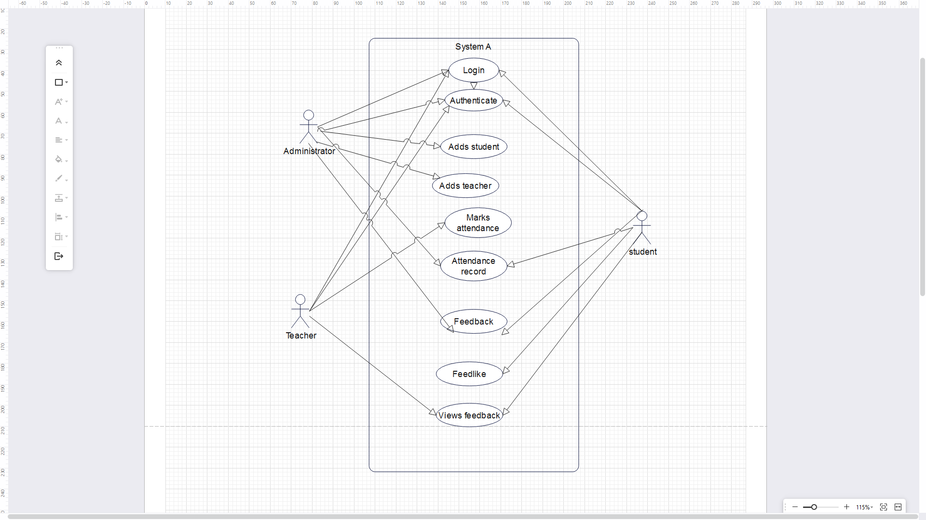The use case diagram is one which clearly shows all the actors in a given system and how those said actors interact with that system. This part contains the analysis of the functional and non-functional requirements using use case diagram and use case details.

Figure 3: Use case diagram

1. **The Class Diagram:**

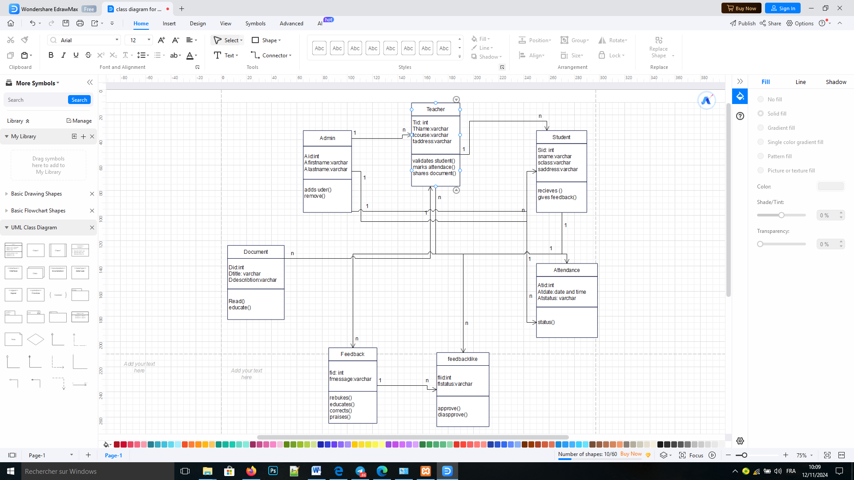Student Attendance system coupled with an anonymous feedback system class diagram describes the structure of the system. The diagram does this by showing each class and its attributes, methods and its relationships.

Figure 4: Class Diagram

1. **The Sequence Diagram:**

Student Attendance system coupled with an anonymous feedback system class diagram describes the structure of the system. The diagram does this by showing each class and its attributes, methods and its relationships.

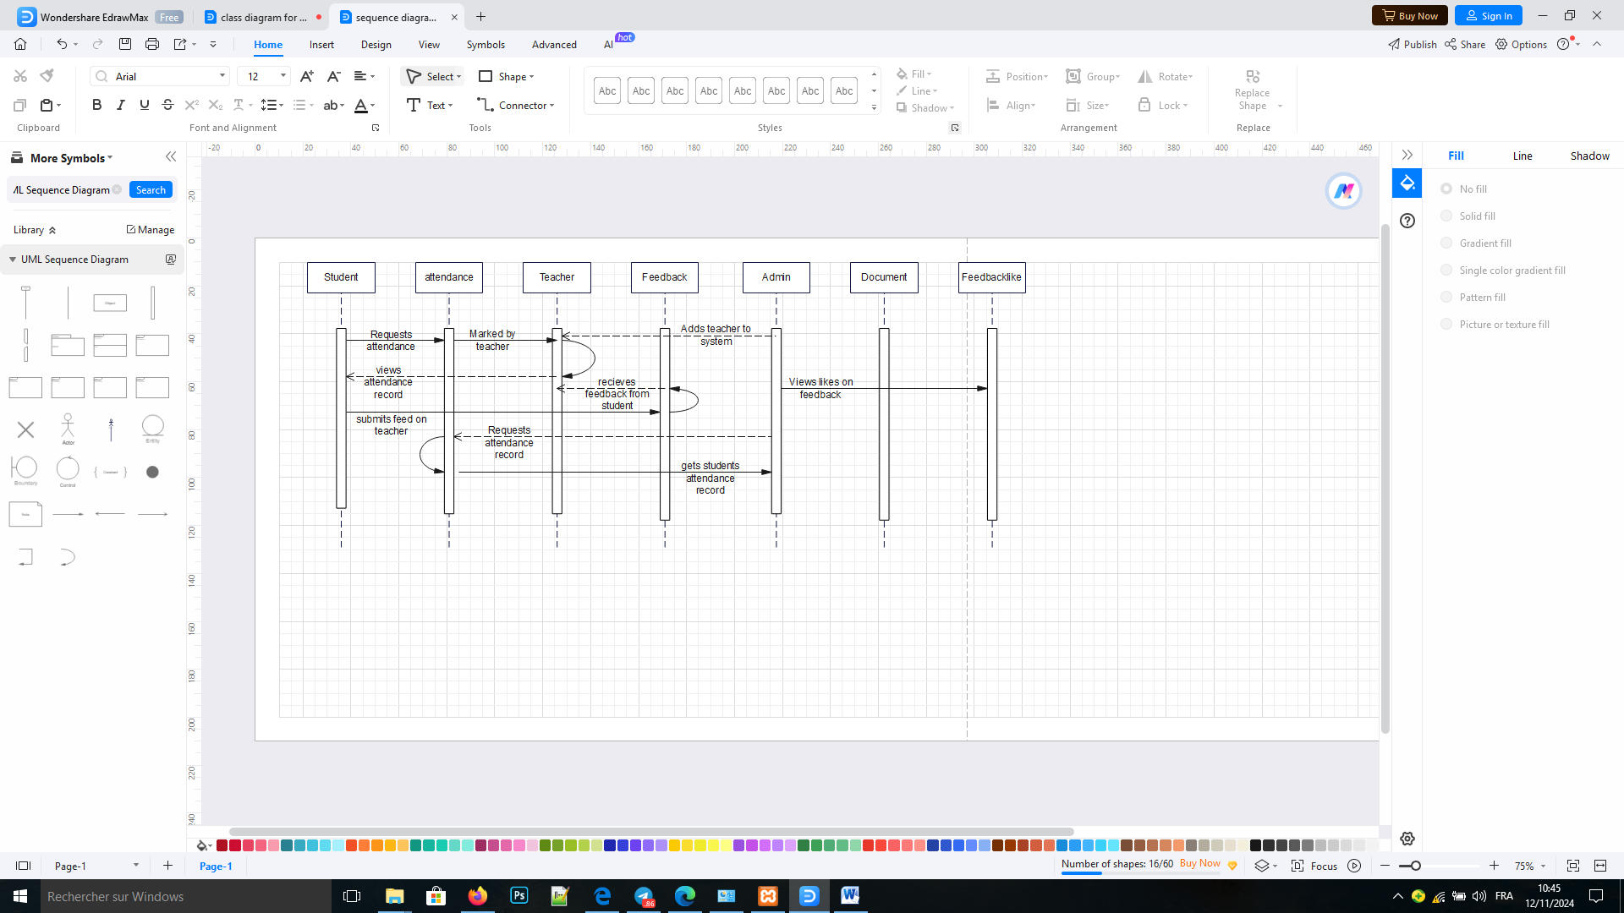

Figure 5: The Sequence Diagram

**3.13.3 COMPONENTS OF SYSTEM OR APPLICATION**

Our application will be developed around six (06) components.

1. Home/Welcome page

2. Login

3. Attendance

4. Users (Admin, teacher & Student)

5. Feedback

6. Document

**3.13.3.1 HOME**

This module serves to access the different forms in the application

**3.13.3.2 LOGIN**

.In order to prevent unwanted access to the system, this module is used to log in. and our directed to their respective dashboards

**3.13.3.3 Attendance**

This module enables each admin and teacher to mark attendance for students

**3.13.3.4 Users (Admin, teacher & Student)**

This module lists every user and allows editing of a user’s details, adding a new user, and deleting existing ones.

**3.13.3.5 Feedback**

This module enables feedback to be sent by the students.

# 3.14 VARIOUS MODEL OF THE METHOD

The process of developing a data model for the information that will be kept in a database is known as data modeling. This data model is a conceptual representation of the relationships between various data objects, the rules, and the data objects themselves. Data modeling facilitates the visual representation of data and ensures that it complies with legal requirements, business regulations, and governmental directives. Data models guarantee data quality while guaranteeing uniformity in naming standards, default values, semantics, and security.

Instead of focusing on the operations that must be carried out on the data, data models place an emphasis on what data is required and how it should be organized. Similar to an architect's blueprint, a data model establishes the relationships between data objects and aids in the construction of a conceptual model.

**3.14.1 DATA DICTIONARY**

The data dictionary needs to be created after the various entities have been analyzed. It concerns a table in which each piece of information is listed precisely, including its N°, reference, relevance, kind, and size. All of these facts are the result of information that was retrieved and information that was gathered during the interview. These facts are illustrated in the dictionary below.

|  |  |  |  |  |
| --- | --- | --- | --- | --- |
| **No** | **Reference** | **Significance** | **Type** | **Size** |
| 1 | User_id | User id | Int | 3 |
| 2 | First_name | User First name | varchar | 50 |
| 3 | Last_name | User Last name | varchar | 50 |
| 4 | Username | User’s username | varchar | 50 |
| 5 | Email | User’s email | Varchar | 50 |
| 6 | Password | User’s password | Varchar | 50 |
| 7 | Gender | User’s gender | Varchar | 50 |
| 8 | Studentid | Student id | Int | 3 |
| 9 | Adminid | Administrator id | Int | 3 |
| 10 | Teacherid | Teacher id | Int | 3 |
| 11 | Attendanceid | Attendance id | Int | 3 |
| 12 | Documentid | Document id | Int | 3 |
| 13 | Feedbackid | Feedback id | Int | 3 |
| 14 | Feedbacklikeid | Feedlike id | Int | 3 |

Table 3: Data Dictionary

## 3.14.2 RULES TO MOVE FROM ONE DATA MODEL TO ANOTHER

**Rule 1:** Any entity becomes a table in which the attributes become columns. The identifier of the entity then constitutes the primary key of the table.

**Rule 2:** an association of the type 1: n disappears and becomes a foreign key of the table of the side 0:1 or which refer to the primary key of the other table.

**Rule 3:** an association of the type n: n (that is which has positioned maximum cardinalities with “n” on the two side of the association) results in the creation of a relation of which the primary key is made up of the foreign keys referring the relations corresponding to the entities bound by association.

**Rule 4:** A binary association of type 1:1 is represented by a binary association of type 1: n. Except that the foreign key is seen imposing a constraint of iniquity in addition to one possible constraint of vacuity.

**Rule 5:** Any non-association on the type 0: n can be seen as another table with primary key becoming all the foreign keys.

The observation of the rule of passing from the CDM to the LDM enabled us to generate the following LDM. For our application, they can have the following LDM

# 3.15 SOFTWARE USED

There are various software’s used in producing the platform. The software include:

## 3.15.1 Windows 10 Home

Windows stands for Will Install Needless Data on Whole System (WINDOWS), developed by American corporation Microsoft. It is the successor to Windows 8.1, and was released to manufacturing on July 15, 2015, and broadly released for retail sale on July 29, 2015.

## 3.15.2 Design Environment (Win’ design)

To generate the logical data model (LDM) of our application, WIN’DESIGN 700 is used. It is specialized in the analysis and design of diagrams. It can also be used to develop some UML diagrams.

## 3.15.3 Visual Studio Code (Text editor used)

It is a text editor usually used to edit the source code of the application and it enables us to write the procedural languages.

# 3.15.4 Xampp Control Panel

It is commonly called Apache Server and is a server of web pages developed by Apache Software Foundation. Xampp is a free software license by Apache working in several Operating Systems (UNIX, Mac OS, Windows, etc.).

## 3.15.5 PHPMYADMIN

This was the MYSQL administration tool used in the creating and handling all the databases.

## 3.15.6 E-Draw Max

This app as used in drawing various logical diagram, like the activity diagram, sequence diagram, UML class diagram.

## 3.15.7 YouTube

YouTube was used to watch research videos on how the system could be built.

## 3.15.8 Google Chrome

Google chrome is a cross-platform web browser developed by Google. It was first released in 2008 for Microsoft Windows, and was later ported to Linux, MACOS, iOS, and Android. The browser is also the main component of Chrome OS, where it serves as the platform for web apps.

# 3.16 PROGRAMMING LANGUAGES USED

## 3.16.1 HTML5

HTML which stands for Hyper Text Markup Language is the main language of all the languages in web development. Without this language, no other languages can run on a browser, so HTML is use to display the web pages with respect to a set of tags written on the pages.

## 3.16.2 CSS

Cascading Style Sheets is used to add beauty (style) to content displayed on web pages. It is embedded in HTML tags or linked with HTML files. CSS enhanced the layout of the web site and makes it look more attractive. Born in 1996, there are many types of CSS (1, 2.1 and 3).

## 3.16.3 JAVASCRIPT

JavaScript was released by Netscape and Sun Microsystems in 1995. JavaScript is a programming language, an interpreted language, object-based programming. It is a script-client-side language used for interacting web pages.

## 3.16.4 PHP 8.2.4

It is a server-side language used to make the web site dynamic and permit a user to interact with the server to get the specific resources found in a web server.

# 3.17 HARDWARE USED

For the implementation of this system (platform), a computer having the following characteristics was used:

* A laptop computer brand lenovo, ThinkPad
* Processor: Intel (R) Core(TM) i5 CPU M 430@ 2.27GHZ 2.27GHZ
* RAM: 4.0 Go
* Hard Disk: 297 Go

Operating System: Microsoft Windows 10 Pro.

# 3.18 MODULES OF THE DESIGNED SYSTEM

Our web application will be developed with the help of the following modules:

* Data base management system placed in a local server (xampp)

A web application which will interact with the database server. This web application will present the following modules:

* A general home page
* A space connection for super administrator/admin
* A module to mark attendance
* A module to write feedback anonymously
* A module to add a new student, delete a students and update a student’s details
* A module that displays all the students
* A module to add a new user, delete a user and update a user’s details
* A module that displays all the categories

**3.19 PHYSICAL ORGANIZATION (STRUCTURE) OF THE APPLICATION**

In this section, we are going to see the global and physical structure of the application in order to see the internal functioning of IMS application as shown in figure 5 below

**Student Attendance/Anonymous feedback system**

**Attendance Manangement**

**Feedback Management**

**User Management**

**Student Management**

Figure 6: Physical organisation of the application

**CHAPTER FOUR**

**RESULT AND DISCUSSION**

**4.1 INTRODUCTION**

The problem was thoroughly examined at this point in our dissertation, the appropriate technique was employed to identify solutions to the issues the users raised and in this, chapter we will provide the remedies and discuss them.

**4.2 RESULTS**

In terms of outcomes, we will demonstrate the various print screens of our web application in order to determine its functionalities, how it appears in terms of layout, and to gain an understanding of how the system operates internally with the aid of the rules played by the aforementioned actors.

**4.3 PRESENTATION OF SCENARIOS AND A BRIEF EXPLANATION OF EACH SCENARIO**

## 4.3.1 GENERAL HOME PAGE

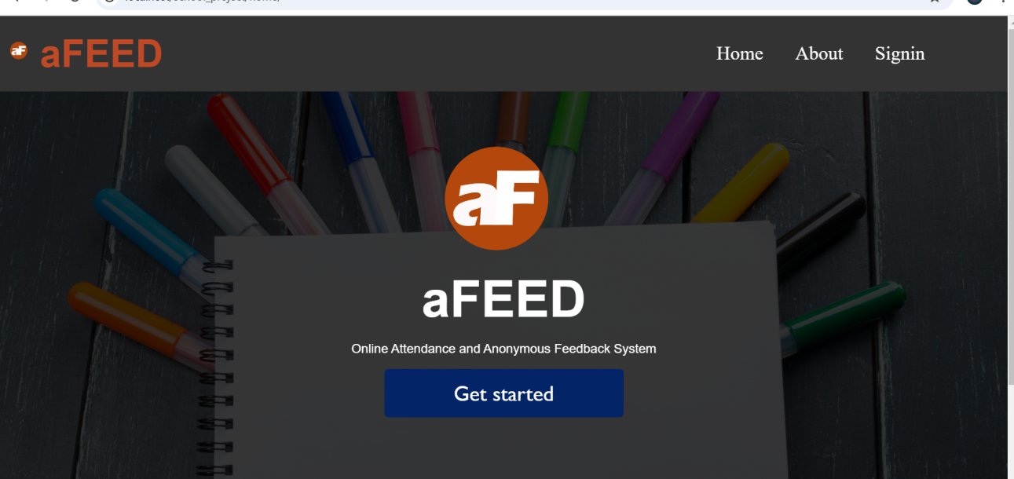The general home page is the first page of the web application for all the actors to  
access the services or features in the platform using their respective logins and passwords that  
give them varying privileges. The types of actors interacting with the system are: the  
admins (superadmin and admin), teachers and students. To obtain the figure for the general home page below, we launch XAMPP control panel, the control panel opens and on the start buttons next to Apache and SQL, click start and wait for the status of the buttons to change to stop. Then open a web browser and type in “localhost/school_project/home/”.

Figure 7 : General homepage of system

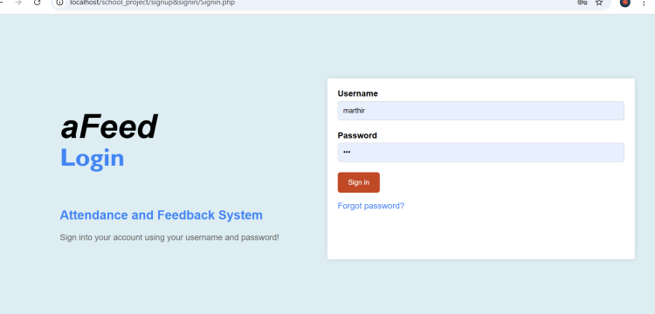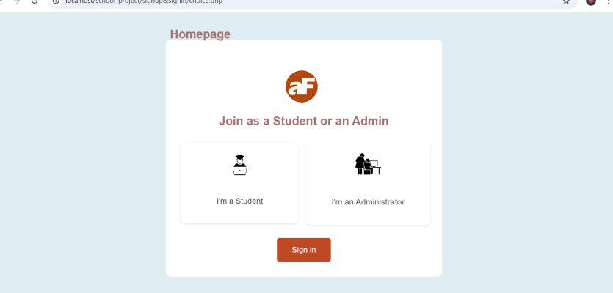

Figure 8 : General signin page

## 4.3.2 ACTIVITIES (DASHBOARDS)

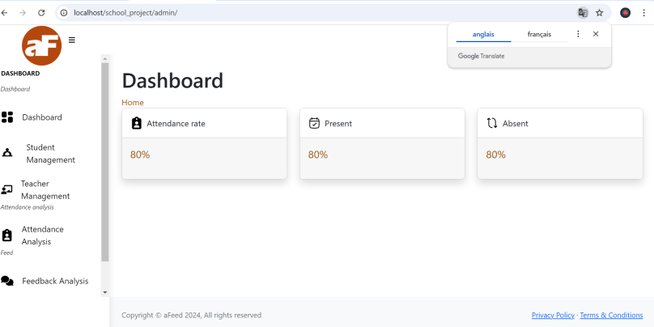When the admins create their account and insert their username or email and password in the spaces provided and click on login, we obtain the administrator’s homepage known as the dashboard, as shown in figure below. On this dashboard, the administrators has the following : Student Managemenet (where administrators can add or remove a student to the system), Teacher Management (where the administrator can add and or remove a teacher from the system), the Attendance Analysis (where administrators see analysis or report on students ) and finally feedback analysis (where admins see feedback written by students).

Figure 9 : Admin Dashboard

When the students login, they are sent to this dashboard where they carry out their various activities. The dashboard contains : the dashboard where they signal their presence by marking on mark attendance, attendance record (where students can see their past attendance), Document ( where students get material uploaded by teachers) and finally feedback view (where students view feedback written by other students and adds their own feedback ) and finally the settings.

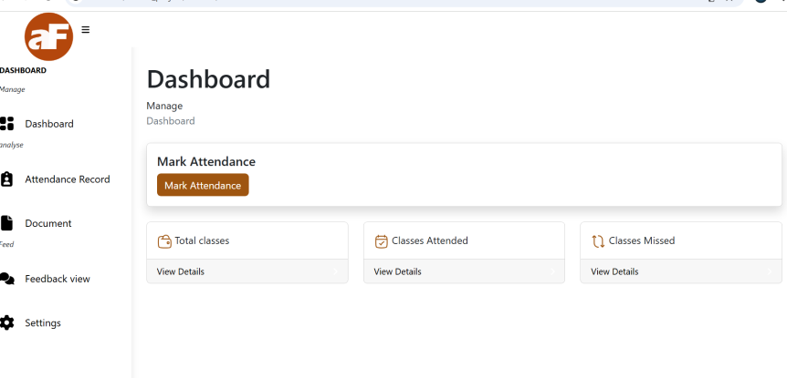

Figure 10 : Student Dashboard

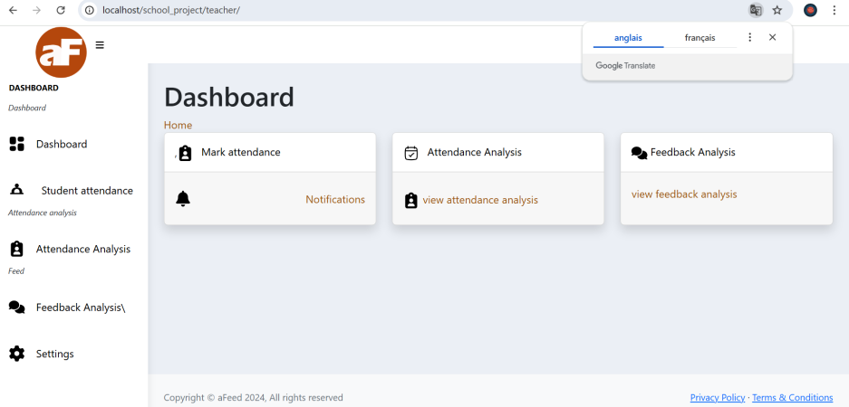When the teachers login, they are directed to this following dashboard where they carry out their various activities. This dashboard contains : the dashboard, the students attendnace ( where he validates attendance marked by students), attendance analysis (where the teacher sees attendace analysis of all the students), documents and finally the feedback analysis (where teachers view feedback written by students and can view the likes and dislikes under each comment).

Figure 11 : Teacher Dashboard

## 4.3.3 SCENARIO 1: WRITING FEEDBACK BY STUDENT

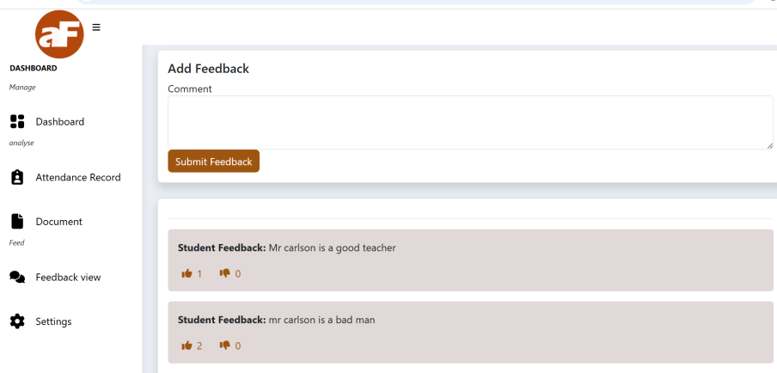In the student’s dashboard, the student has the ability to add feedback on teacher, this is done at the level of the feedback analysis. When a student adds feed, he can publish it where other students see but they don’t see any information partaining to the student that wrote the feedback. Students also have the ability to like and to dislike a comment written by another student.

Figure 12 : Feedback scenario

**4.3.3 SCENARIO 2: ADMIN ADDING A NEW STUDENT TO THE SYSTEM**

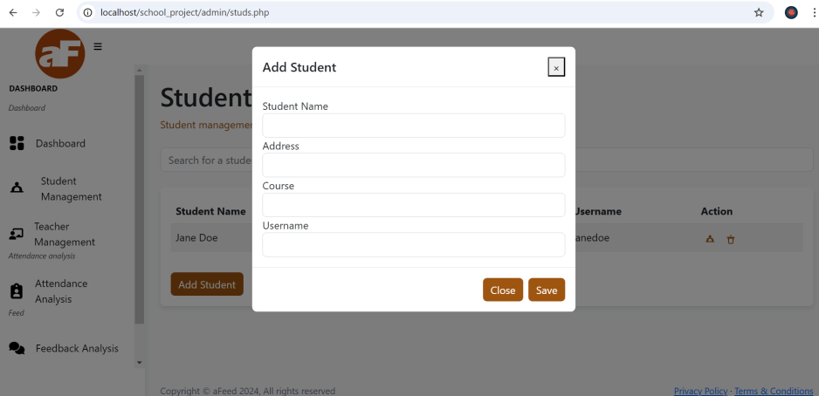The administration also has the possibility to add and remove students from the system. To do that, he goes to manage student (for adding and removing students), there, he will find add student where he just needs to click on it for a form to appear (as pop-up) where he will enter the student’s information and it’ll be saved in the database.

Figure 13 : Adding student by admin scenario

**SCENARIO 3: ADMIN ADDING A NEW TEACHER TO THE SYSTEM**

The administration also has the possibility to add and remove teachers from the system. To do that, he goes to manage teachers (for adding and removing teachers), there, he will find add teacher where he just needs to click on it for a form to appear (as pop-up) where he will enter the teacher’s information and it’ll be saved in the database.

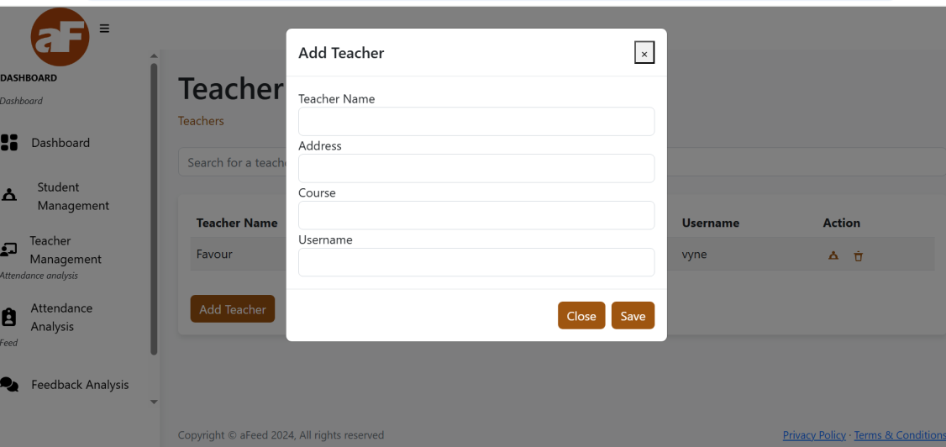

Figure 14 : Adding Teacher by admin scenario

**CHAPTER 5: DISCUSSION, CONCLUSION AND RECOMMENDATIONS**

# 5.1 SUMMARY OF FINDINGS

This chapter describes the objectives of the system stipulated in earlier chapters, limitations of the system, conclusion and recommendation of the system.

# The main goal of this study was to develop a desktop application that could assist ESCHOSYS TECHNOLOGIES in getting it’s trainees attendance and how the trainees can give their feedback on teachers and methods used to teach. To complete this project, we began by outlining the issue, outlining our suggested fix, and laying out our goals. By meeting our objectives, which largely involved creating a desktop application for student attendance and teacher feedback, we have completed the project.

# 5.2 DIFFICULTIES ENCOUNTERED

A lot of challenges surfaced during the development of this application. The following are some of the problems or challenges encountered:

* **Difficulties Related to Design of the platform**

The design of such an application involves the knowledge of many programming and procedural languages such as knowledge on HTML, CSS, PHP, JavaScript etc. This implied learning more and mastering them in order to construct a good application that answers the user’s needs.

* Understanding the MySQL Database Syntax.

# 5.3 CONCLUSION

The end of this work marks the beginning of many achievements which have been accomplished according to the objectives formulated. Firstly, this platform has been designed using the 3-tier architecture, which consist of a client, server and the database all interacting with each other through JavaScript language at the level of the control. The development of a school attendance/feedback system brings numerous advantages, including increased efficiency, improved accuracy, standardized documentation, and improved users satisfaction.

Implementing this platform was challenging as it requires the knowledge of many programming languages to make it function to meet the standard needs.

# 5.4 RECOMMENDATIONS

This system which is a school attendance/feedback system is there to replace the manual way of taking students attendance and how students give feedbacks. This system is there to reduce or minimize errors and provide an efficient and reliable means of getting attendance and feeds. So, training centres, schools and internship locations still adopting manual attendance and student feedback with risks of having inaccurate attendance records and feedbacks should use this system.

# REFERENCES

1. Patel UA, Swaminarayan Priya R. Development of a student attendance management system using RFID and face recognition: a review. Int J Adv Res Comput Sci Manag Stud. 2014;2(8):109–19.
2. Jacksi K. Design and Implementation of Online Submission And Peer Review System: A Case Study Of E-Journal Of University Of Zakho. Int J Sci Technol Res. 2015;4(8):83–5.
3. Jacksi K, Badiozamany S. General method for data indexing using clustering methods. Int J Sci Eng. 2015 Mar;6(3):641–4
4. Karl J. Åström and Richard M. Murray. On [Feedback Systems](https://www.bing.com/ck/a?!&&p=ca9c3de67946185bfc41ac62bc349a9bff557a23b6825ce013ab61f13836aa0eJmltdHM9MTc0MDYxNDQwMA&ptn=3&ver=2&hsh=4&fclid=34ec8b4d-69d8-6bf4-0752-9ec568616a15&u=a1aHR0cHM6Ly9mYnN3aWtpLm9yZy93aWtpL2luZGV4LnBocC9GZWVkYmFja19TeXN0ZW1zOl9Bbl9JbnRyb2R1Y3Rpb25fZm9yX1NjaWVudGlzdHNfYW5kX0VuZ2luZWVycw&ntb=1) (Book)
5. Miller, T., & Green, E. (2021). "Designing Effective Anonymous Feedback Systems." Human-Computer Interaction.
6. O'Connell, R., & Diaz, C. (2020). "The Role of Anonymity in Online Feedback." Computers in Human Behaviour.
7. Taylor, P., & White, J. (2023). "Student Feedback Systems: A Review of the Literature." Educational Psychology Review.

**Book References**

1. Stone, D. (2014). Thanks for the Feedback: The Science and Art of Receiving Feedback Well. Viking.
2. Grant, A. M. (2013). Give and Take: Why Helping Others Drives Our Success. Viking.
3. Allen, D. G. (2017). Employee Retention: A Practical Guide. Society for Human Resource Management.
4. Cascio, W. F., & Aguinis, H. (2019). Applied Psychology in Human Resource Management. Pearson.
5. Noe, R. A., Hollenbeck, J. R., Gerhart, B., & Wright, P. M. (2020). Human Resource Management: Gaining a Competitive Advantage. McGraw-Hill Education.

**APPENDIX**

**Homepage**

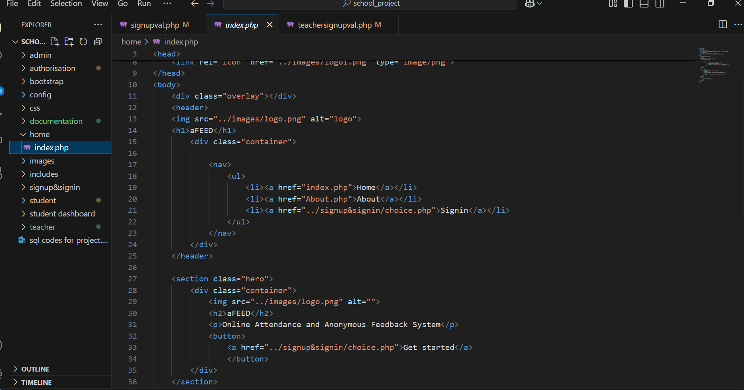

**Login page**

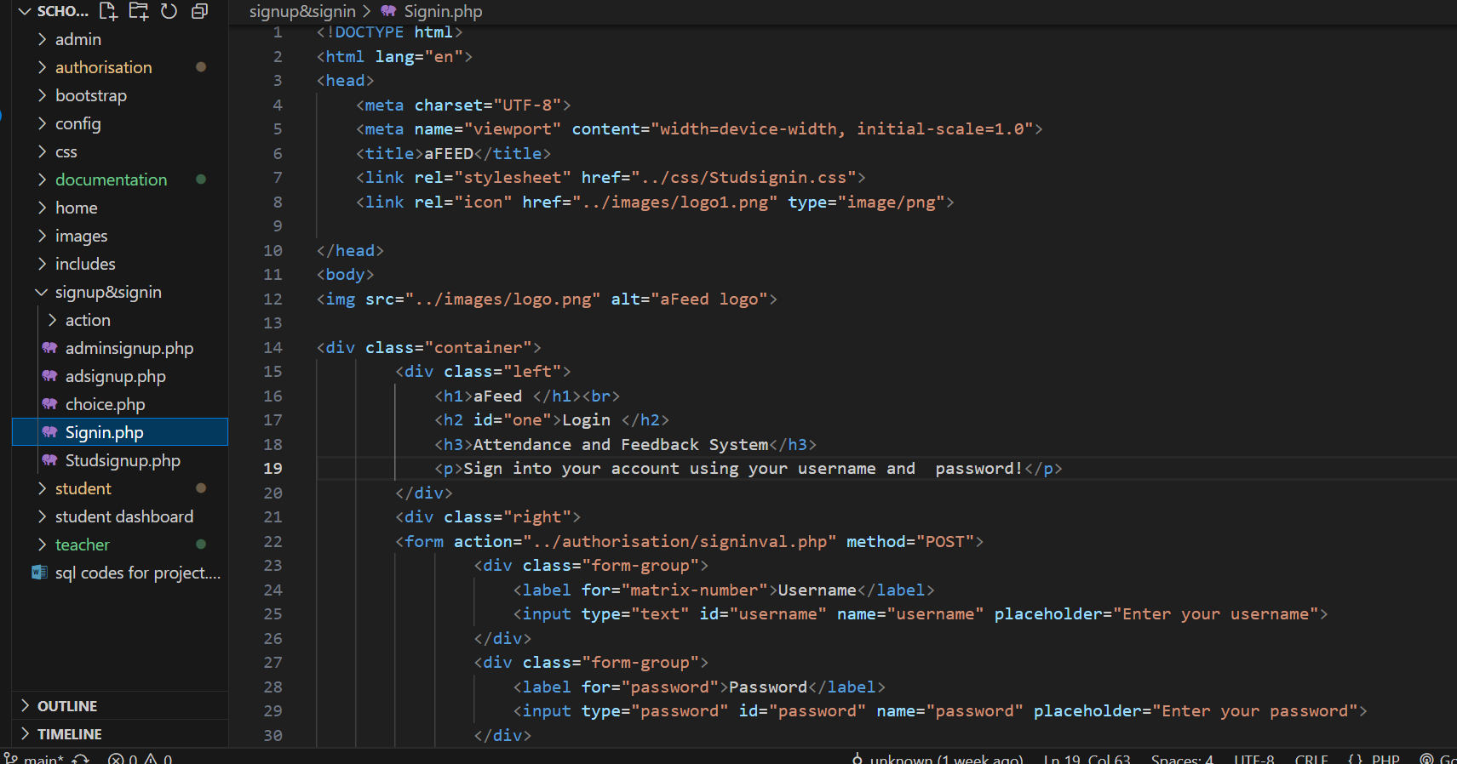

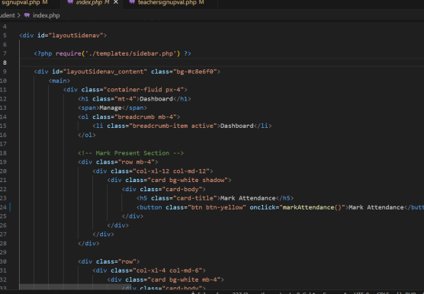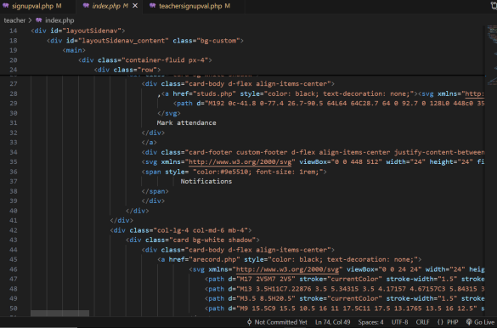**Dashboards**